Sleek on-the-go storage

[Watch Video](https://www.kingston.com/en/video/play?videoId=PvaNtN80P7DlwsYaerzhvWI4esZdHC-6GcOnXbGnoTC8X9Q71i_P7_xwGR8orp56VrTr7dBNEXJG0yW32Z5MCA2&start=0&autoPlay=False&chromeless=False&captionOption=No)

DTXON

* [Intro](https://www.kingston.com/en/usb-flash-drives/datatraveler-exodia-onyx-moving-usb-3-2-usb-flash-drive#product-features)
* [Specifications](https://www.kingston.com/en/usb-flash-drives/datatraveler-exodia-onyx-moving-usb-3-2-usb-flash-drive#specifications)
* [Resources](https://www.kingston.com/en/usb-flash-drives/datatraveler-exodia-onyx-moving-usb-3-2-usb-flash-drive#links)
* [Datasheet](https://www.kingston.com/datasheets/dtxon_us.pdf)

[**Buy**](https://www.kingston.com/en/usb-flash-drives/datatraveler-exodia-onyx-moving-usb-3-2-usb-flash-drive#atc)

DataTraveler Exodia Onyx USB Flash Drivewith sleek moving cap

Kingston DataTraveler® Exodia™ Onyx is a USB 3.2 Gen 1 compliant1 flash drive that delivers quick transfers for simple and easy storage. Designed with a sleek matte black casing, the DT Exodia Onyx is the perfect affordable companion for stylish storage. The drive is available in capacities up to 256GB2.

DT Exodia Onyx is backed by a five-year warranty, free technical support and legendary Kingston® reliability.

* Moving cap design protects USB connector
* Sleek matte black casing
* Loop easily attaches to key ring

Key Features



Refined yet functional design

Sleek matte black casing paired with a moving cap protects USB connector and your data when not in use.



Reliable performance

The lightweight USB 3.2 Gen 1 compliant1 storage solution delivers quick file transfers.



Ultimate portability

Loop easily attaches to key rings for perfect on-the-go storage.

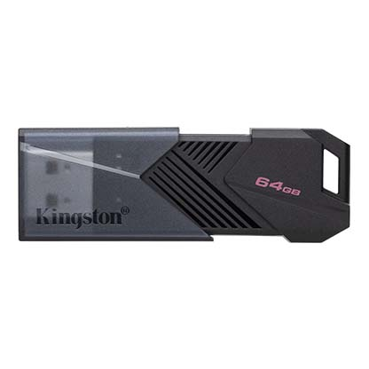

* [DataTraveler Exodia Onyx USB Flash Drive - 64GB](javascript:void(0))
* [DataTraveler Exodia Onyx USB Flash Drive - 64GB](javascript:void(0))
* [DataTraveler Exodia Onyx USB Flash Drive - 64GB](javascript:void(0))

Capacity

 64GB

 128GB

 256GB

* Part Number: DTXON/64GB
* USB 3.2 Gen 1 compliant
* 5-year warranty

[**Where to Buy**](https://www.kingston.com/en/wheretobuy)